CPE301 – SPRING 2019

Design Assignment 4A

Student Name: Jeb Mrinas

Student #: 5003376451

Student Email: marinj4@unlv.nevada.edu

Primary Github address: https://github.com/jebmarinas

Directory: https://github.com/jebmarinas/assignment_projects

1. **COMPONENTS LIST AND CONNECTION BLOCK DIAGRAM w/ PINS**

List of Components used:

ATmega328PB

Multifunction Shield

Breadboard

DC Motor

MD08A

Block diagram with pins used in the Atmega328PB:

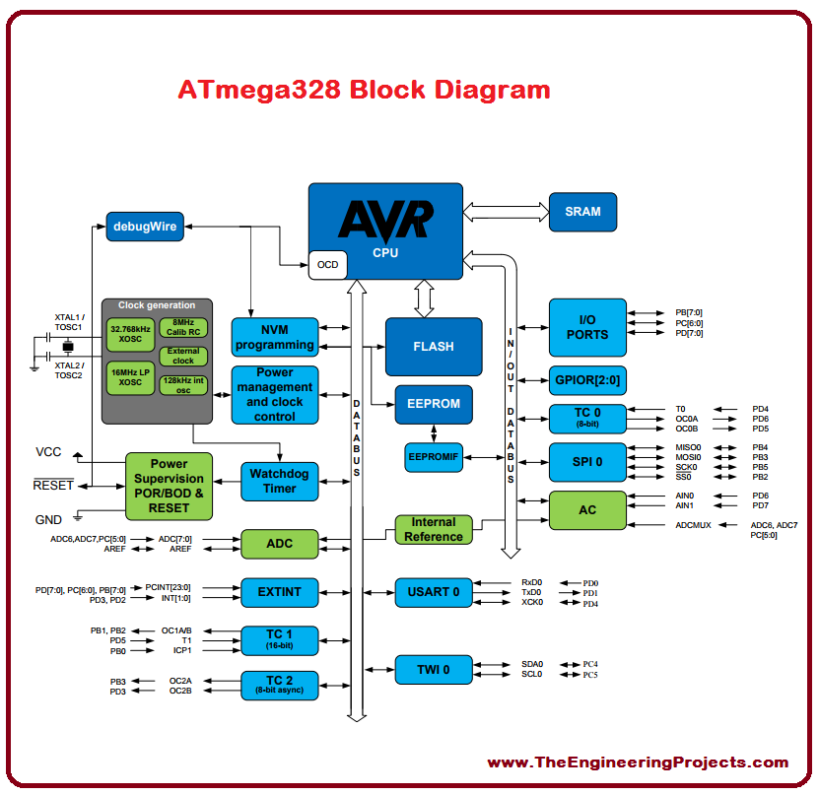

1. **INITIAL/MODIFIED/DEVELOPED CODE OF TASK 1/A**

#define *F_CPU* 16000000UL

#include <avr/io.h>

#include <util/delay.h>

#include <avr/interrupt.h>

#include <stdio.h>

volatile float adc_temp;

void adc_init(void)

{

ADMUX = (0<<REFS1)| // reference selection bit

(1<<REFS0)| //AVCC EXTERNAL CAP AT REF

(1<<ADLAR)| //ADC LEFT ADJUST RESULT

(0<<MUX2)| //ANALOG CHANNEL SELECTION BITS

(0<<MUX1)| //ADC

(0<<MUX0);

ADCSRA = (1<<ADEN)| // ADC ENABLE

(0<<ADSC)| // ADC START CONVERSION

(0<<ADATE)| // ADC AUTO TRIGGER ENABLE

(0<<ADIF)| // ADC INTERRUPT ENABLE

(0<<ADIE)|// ADC PRESCALER SELECT BIT

(1<<ADPS2)|

(1<<ADPS1)|

(1<<ADPS0); // SELECT CHANNEL

}

void read_adc(void)

{

unsigned char i = 4;

adc_temp = 0;

while(i--)

{

ADCSRA |=(1<<ADSC);

while(ADCSRA & (1<<ADSC));

adc_temp += ADC;

*_delay_ms*(50);

}

adc_temp = (adc_temp/8);

}

ISR(PCINT1_vect)

{

DDRC ^= (1<<0);

}

int main()

{

adc_init();

DDRC |= (0<<3);

PORTC |= (1<<3);

PORTC |= (1<<0);

DDRB |= (1<<DDB1);

PCICR = (1<<PCIE1);

PCMSK1 = (1<<PCINT11);

sei();

ICR1 =0xFFFF;

TCCR1A |= (1<<COM1A1)|(1<<COM1B1);

TCCR1A |= (1<<WGM11);

TCCR1B |= (1<<WGM12)|(1<<WGM13);

TCCR1B |= (1<<CS10);

while(1)

{

read_adc();

*_delay_ms*(50);

if((adc_temp >= 62237) && (adc_temp < 65456))

{

OCR1A = 62237;

*_delay_ms*(50);

}

else

{

OCR1A = 0x00;

}

return 0;

}

}

1. **SCREENSHOTS OF EACH TASK OUTPUT (ATMEL STUDIO OUTPUT)**
2. **SCREENSHOT OF EACH DEMO (BOARD SETUP)**

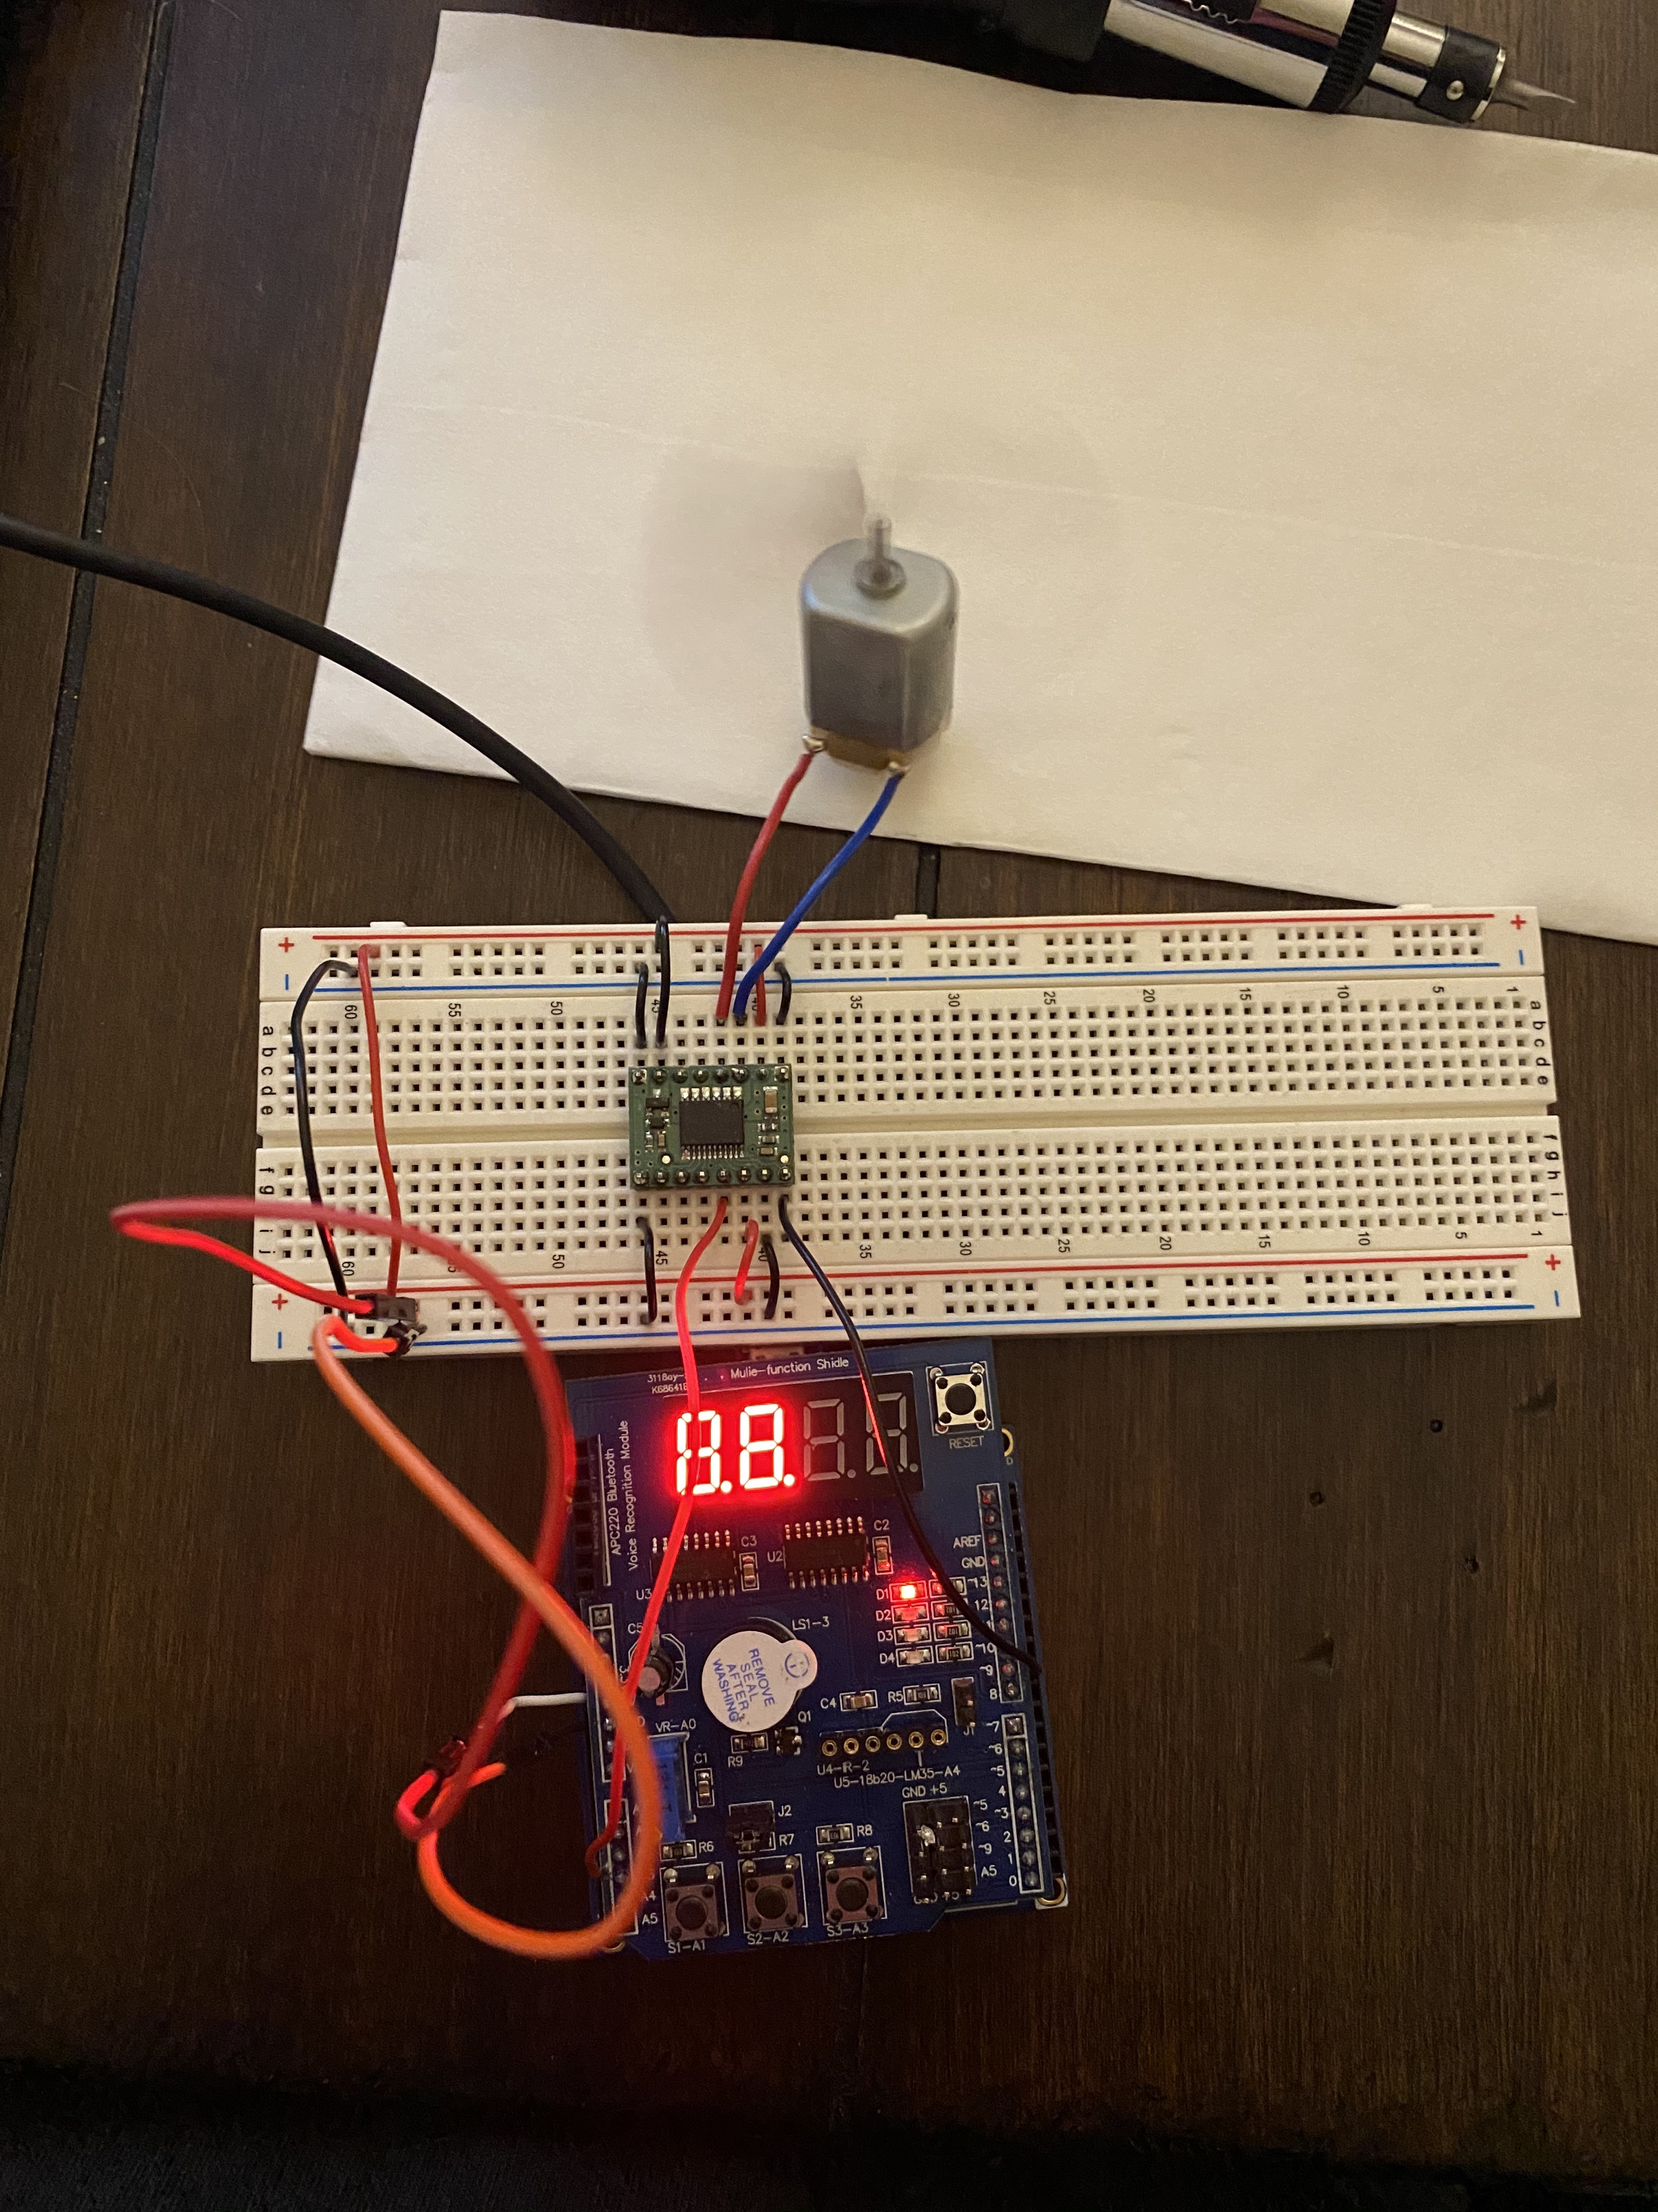

1. **VIDEO LINKS OF EACH DEMO**

<https://youtu.be/O3Gi2yYKH8c>

1. **GITHUB LINK OF THIS DA**

<https://github.com/jebmarinas/Assignment_projects/tree/master/Assignment4a/Assignment4A>

**Student Academic Misconduct Policy**

<http://studentconduct.unlv.edu/misconduct/policy.html>

“This assignment submission is my own, original work”.